79

Service Learning Project Development
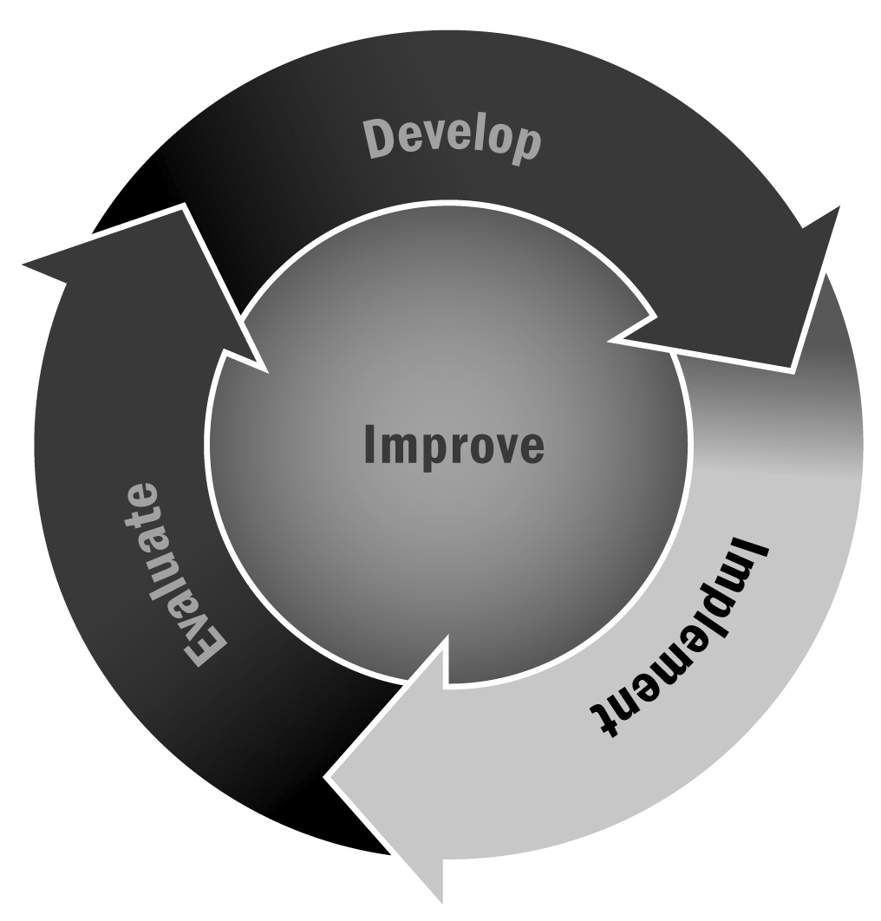
In Chapter 4, you learned that service learning is an activity that promotes many of the youth development principles (e.g., connection with the community) and practices (e.g., youth decision-making, leadership, and reflection). Staff members can use service learning activities or projects to help improve youth academic achievement, develop their leadership skills, strengthen ties to the community, and provide real-life experience.
Directions: Use this template in partnership with youth to design a service learning project. There are a variety of ways to come up with a service learning project. You can use the Community Inventory for Service Learning (Tool 78). We also suggest identifying your service learning project through a youth-led asset mapping activity (Tool 34) or conducting a youth-researched market analysis (Tool 15) or a needs assessment (Tool 35). Ideally, youth should drive the development of the activity. Younger youth may need additional support to complete this template. Staff members should provide support and guidance throughout the process.

Service Learning Project Plan
Project Name:
Subject Area/Grade Level:
Purpose of the Project:
Provide a short description of the service learning project and issue that will be addressed:

Task | What Is Needed? | Resources Available? | Strategies/Action Steps | Who Is Responsible?
Scheduling the service project (i.e., logistics)
Permission process (e.g., parents, release time)
Transportation (i.e., how youth will get to service site)
Identifying needs of community
Outreach to community partner
Documentation of service project (i.e., hours spent, credit)
Safety/risk management
Fundraising (e.g., for additional activities)
Other
Academic Goals
List the academic subject area(s) and corresponding learning standard(s) that the project will address.

Civic Goals
List the knowledge, skills, and competencies that will be emphasized in the project.
Youth Voice and Choice
What opportunities for youth to take on leadership roles exist for this project?

Timeline
How much time will you need to complete this project? Develop a detailed timeline with a clear start and end date and milestones along the way. Make sure to give the project enough time to make progress and see the results of your work.
Start date:
Milestone 1:
Milestone 2:
Milestone 3:
Milestone 4:
End date:

Celebrating Your Project Through a Culminating Event
How will you celebrate the achievement when the project is done? How will you involve and celebrate the community?

Reflection
How you will you reflect on and share your growth at the conclusion of this project?

Evaluation
How you will you evaluate the success of the project, including progress toward expected goals and outcomes for the community?

